Residual V2

0. Environment

|  |  |
| --- | --- |
| DataSet | CIFAR-10 |
| Language | Python3.5 & Tensorflow 1.0 |
| optimizer | Adam |
| Loss function | Cross entropy Loss |

Input : 32x32x3 size image

1. initialize

|  |  |
| --- | --- |
| layer | 3x3 conv (filter = 64, pad) |
| output | 32x32x64 |

2. module (5 times)

|  |  |
| --- | --- |
| Layer | 3x3 conv (filter = 64, pad) |
| Output #1 | 32x32x64 |
| Layer | relu |
| Output #2 | 32x32x64 |
| Layer | 3x3 conv (filter = 64, pad) |
| Output #3 | 32x32x64 |
| Layer | Output #3 + Input #1 |
| Output #4 | 32x32x64 |
| Layer | relu |
| Output | 32x32x64 |

3. Average_pool

|  |  |
| --- | --- |
| layer | 1x1 conv (filter = 1000) |
| output | 32x32x1000 |
| layer | 1x1 conv (filter = 10) |
| output | 32x32x10 |
| layer | 32x32 average_pool |
| output | 10 |

4. Overall

|  |  |
| --- | --- |
| Training(7600 iteration) | Time : 22149.313006162643 seconds |
| Accuracy : 0.768 |
| Validation | Accuracy : 0.674 |
| Re-training(64 iteration) | Accuracy : 0.75 |
| Re-Validation | Accuracy : 0.674 |
| Test | Acurracy : 0.686 |

Training

Iteration 0: with minibatch training loss = 14.4 and accuracy of 0.11

Iteration 100: with minibatch training loss = 1.96 and accuracy of 0.33

Iteration 200: with minibatch training loss = 1.88 and accuracy of 0.23

Iteration 300: with minibatch training loss = 1.79 and accuracy of 0.31

Iteration 400: with minibatch training loss = 1.94 and accuracy of 0.3

Iteration 500: with minibatch training loss = 1.68 and accuracy of 0.38

Iteration 600: with minibatch training loss = 1.43 and accuracy of 0.52

Iteration 700: with minibatch training loss = 1.5 and accuracy of 0.39

Epoch 1, Overall loss = 1.89 and accuracy of 0.343

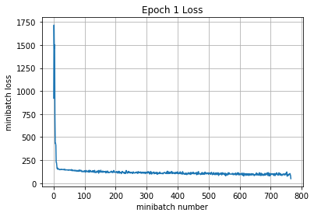

Iteration 800: with minibatch training loss = 1.66 and accuracy of 0.38

Iteration 900: with minibatch training loss = 1.46 and accuracy of 0.44

Iteration 1000: with minibatch training loss = 1.63 and accuracy of 0.48

Iteration 1100: with minibatch training loss = 1.21 and accuracy of 0.61

Iteration 1200: with minibatch training loss = 1.43 and accuracy of 0.47

Iteration 1300: with minibatch training loss = 1.27 and accuracy of 0.55

Iteration 1400: with minibatch training loss = 1.14 and accuracy of 0.62

Iteration 1500: with minibatch training loss = 1.21 and accuracy of 0.53

Epoch 2, Overall loss = 1.34 and accuracy of 0.507

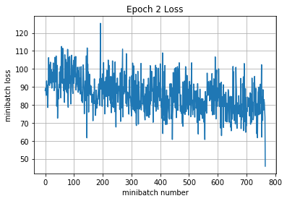

Iteration 1600: with minibatch training loss = 1.39 and accuracy of 0.53

Iteration 1700: with minibatch training loss = 1.15 and accuracy of 0.58

Iteration 1800: with minibatch training loss = 1.29 and accuracy of 0.56

Iteration 1900: with minibatch training loss = 1.15 and accuracy of 0.64

Iteration 2000: with minibatch training loss = 1.29 and accuracy of 0.56

Iteration 2100: with minibatch training loss = 1.4 and accuracy of 0.58

Iteration 2200: with minibatch training loss = 1.14 and accuracy of 0.61

Epoch 3, Overall loss = 1.18 and accuracy of 0.576

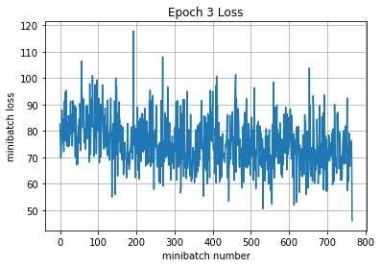

Iteration 2300: with minibatch training loss = 1 and accuracy of 0.69

Iteration 2400: with minibatch training loss = 1.28 and accuracy of 0.5

Iteration 2500: with minibatch training loss = 1.09 and accuracy of 0.58

Iteration 2600: with minibatch training loss = 0.949 and accuracy of 0.61

Iteration 2700: with minibatch training loss = 0.999 and accuracy of 0.56

Iteration 2800: with minibatch training loss = 1.14 and accuracy of 0.66

Iteration 2900: with minibatch training loss = 1.04 and accuracy of 0.61

Iteration 3000: with minibatch training loss = 1.02 and accuracy of 0.66

Epoch 4, Overall loss = 1.06 and accuracy of 0.622

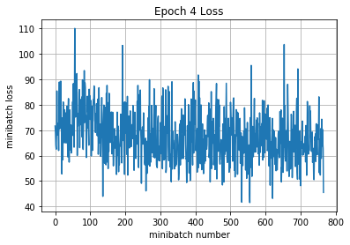

Iteration 3100: with minibatch training loss = 0.856 and accuracy of 0.75

Iteration 3200: with minibatch training loss = 0.61 and accuracy of 0.81

Iteration 3300: with minibatch training loss = 1.22 and accuracy of 0.55

Iteration 3400: with minibatch training loss = 0.957 and accuracy of 0.62

Iteration 3500: with minibatch training loss = 0.872 and accuracy of 0.69

Iteration 3600: with minibatch training loss = 0.976 and accuracy of 0.61

Iteration 3700: with minibatch training loss = 0.907 and accuracy of 0.62

Iteration 3800: with minibatch training loss = 0.923 and accuracy of 0.67

Epoch 5, Overall loss = 0.961 and accuracy of 0.659

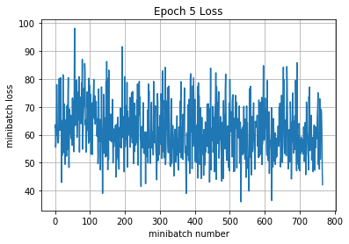

Iteration 3900: with minibatch training loss = 0.696 and accuracy of 0.75

Iteration 4000: with minibatch training loss = 0.915 and accuracy of 0.69

Iteration 4100: with minibatch training loss = 0.805 and accuracy of 0.64

Iteration 4200: with minibatch training loss = 1.04 and accuracy of 0.66

Iteration 4300: with minibatch training loss = 0.768 and accuracy of 0.77

Iteration 4400: with minibatch training loss = 0.816 and accuracy of 0.75

Iteration 4500: with minibatch training loss = 0.936 and accuracy of 0.62

Epoch 6, Overall loss = 0.878 and accuracy of 0.691

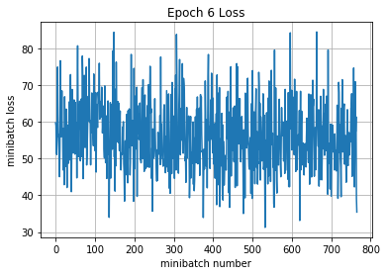

Iteration 4600: with minibatch training loss = 0.763 and accuracy of 0.67

Iteration 4700: with minibatch training loss = 0.879 and accuracy of 0.66

Iteration 4800: with minibatch training loss = 0.792 and accuracy of 0.73

Iteration 4900: with minibatch training loss = 0.964 and accuracy of 0.66

Iteration 5000: with minibatch training loss = 0.757 and accuracy of 0.75

Iteration 5100: with minibatch training loss = 0.874 and accuracy of 0.72

Iteration 5200: with minibatch training loss = 0.907 and accuracy of 0.66

Iteration 5300: with minibatch training loss = 0.802 and accuracy of 0.66

Epoch 7, Overall loss = 0.81 and accuracy of 0.715

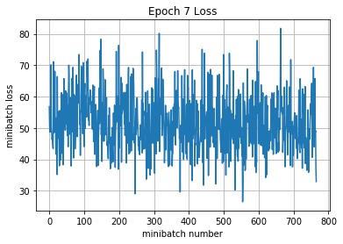

Iteration 5400: with minibatch training loss = 0.928 and accuracy of 0.59

Iteration 5500: with minibatch training loss = 0.68 and accuracy of 0.84

Iteration 5600: with minibatch training loss = 0.611 and accuracy of 0.72

Iteration 5700: with minibatch training loss = 0.725 and accuracy of 0.75

Iteration 5800: with minibatch training loss = 0.942 and accuracy of 0.66

Iteration 5900: with minibatch training loss = 0.736 and accuracy of 0.69

Iteration 6000: with minibatch training loss = 0.873 and accuracy of 0.73

Iteration 6100: with minibatch training loss = 0.489 and accuracy of 0.81

Epoch 8, Overall loss = 0.75 and accuracy of 0.738

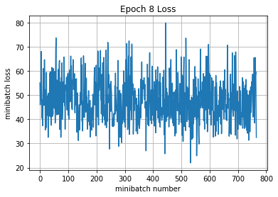

Iteration 6200: with minibatch training loss = 0.692 and accuracy of 0.75

Iteration 6300: with minibatch training loss = 0.849 and accuracy of 0.69

Iteration 6400: with minibatch training loss = 0.703 and accuracy of 0.75

Iteration 6500: with minibatch training loss = 0.653 and accuracy of 0.81

Iteration 6600: with minibatch training loss = 0.537 and accuracy of 0.86

Iteration 6700: with minibatch training loss = 0.478 and accuracy of 0.86

Iteration 6800: with minibatch training loss = 0.402 and accuracy of 0.92

Epoch 9, Overall loss = 0.706 and accuracy of 0.752

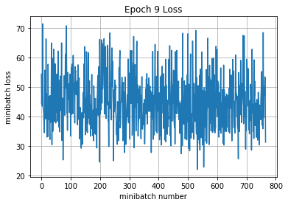

Iteration 6900: with minibatch training loss = 0.666 and accuracy of 0.75

Iteration 7000: with minibatch training loss = 0.756 and accuracy of 0.75

Iteration 7100: with minibatch training loss = 0.834 and accuracy of 0.7

Iteration 7200: with minibatch training loss = 0.556 and accuracy of 0.78

Iteration 7300: with minibatch training loss = 0.839 and accuracy of 0.73

Iteration 7400: with minibatch training loss = 0.472 and accuracy of 0.83

Iteration 7500: with minibatch training loss = 0.493 and accuracy of 0.83

Iteration 7600: with minibatch training loss = 0.649 and accuracy of 0.73

Epoch 10, Overall loss = 0.664 and accuracy of 0.768

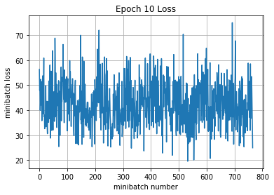

22149.313006162643

Validation

Epoch 1, Overall loss = 0.933 and accuracy of 0.674

Training

Epoch 1, Overall loss = 0.7 and accuracy of 0.75

Validation

Epoch 1, Overall loss = 0.933 and accuracy of 0.674

Test

Epoch 1, Overall loss = 0.906 and accuracy of 0.686